*Motor:*

NTM Prop Drive Series 28-30S 900kv / 270w (short shaft version)

<https://www.hobbyking.com/hobbyking/store/uh_viewItem.asp?idproduct=25081.html>

(+ NTM Prop Drive 28 Series Accessory Pack) <https://www.hobbyking.com/hobbyking/store/__16719__NTM_Prop_Drive_28_Series_Accessory_Pack.html>

[Motor Specs]

[Accessory Pack]

*ESC:*

TURNIGY Plush 25amp Speed Controller

<https://www.hobbyking.com/hobbyking/store/uh_viewItem.asp?idproduct=2163.html>

[ESC Specs]

*Programming Card:*

TURNIGY BESC Programming Card

<https://www.hobbyking.com/hobbyking/store/uh_viewItem.asp?idproduct=2169.html>

*Battery:*

ZIPPY Traxxas 8400mAh 3S1P 30C Lipo Pack (Suits TRA2878)

<https://www.hobbyking.com/hobbyking/store/uh_viewItem.asp?idproduct=37359.html>

[Battery Specs]

*Propellers:*

11x4.7 SF Props 4pc Standard Rotation (Yellow)

<https://www.hobbyking.com/hobbyking/store/uh_viewItem.asp?idproduct=25310.html>

[Propeller Specs]

*Propellers (R/H Rotation):*

11x4.7 SF Props 4pc R/H Rotation (Yellow)

<https://www.hobbyking.com/hobbyking/store/uh_viewItem.asp?idproduct=25311.html>

[Propeller Specs]

*IMU:*

Invensense MPU-9150 standard breakout board από το ebay. Έχει κ η Sparkfun αλλά είναι 6 φορές πιο ακριβό και χωρίς voltage regulator, σε αντίθεση με την απλή breakout των 6.30 €.

*XBee Programmers:*

XBee Explorer USB <https://www.sparkfun.com/products/11812>

Hookup Guide

<https://learn.sparkfun.com/tutorials/exploring-xbees-and-xctu>

Παλιότερα υλικά που αποσύρθηκαν:

*IMU:*

9 Degrees of Freedom IMU Breakout - LSM9DS0 <https://www.sparkfun.com/products/12636>

Hookup Guide

<https://learn.sparkfun.com/tutorials/lsm9ds0-hookup-guide>

**Motor Specs:**

Specs:

Model: **NTM Prop Drive Series 28-30S 900kv (short shaft version)**

Kv: **900rpm/v**

Max current: **18A**

Max Power: **215W @ 12v (3S) / 270W @ 15v (4S)**

Shaft: **3mm**

Weight: **66g**

ESC: **25~30A**

Cell count: **3s~4s Lipoly**

Bolt holes: **16mm & 19mm**

Bolt thread: **M3**

Connection: **3.5mm Bullet-connector**

**Prop Tests:**

13x4E - 11.1v - 194W - 17.4A - 1.04kg thrust

12x6E - 11.1v - 195W - 17.8A - 1.01kg thrust

11x7E - 11.1v - 188W - 17.0A - 0.89kg thrust

10x5E - 11.1v - 133W - 12.0A - 0.75kg thrust

9x6E - 11.1v - 120W - 10.7A - 0.68kg thrust

9x6E - 14.8v - 234W - 15.8A - 1.05kg thrust

8x4E - 14.8v - 159W - 10.6A - 0.75kg thrust

PRODUCT ID: NTM2830S-900

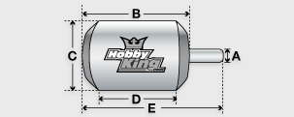

|  |  |
| --- | --- |
| Kv(rpm/v) | 900 |
| Weight (g) | 66 |
| Max Current(A) | 18 |
| Resistance(mh) | 0 |
| Max Voltage(V) | 15 |
| Power(W) | 270 |
| Shaft A (mm) | - |
| Length B (mm) | 30 |
| Diameter C (mm) | 28 |
| Can Length (mm) | 18 |
| Total Length E (mm) | 33 |

*Με 11.1 V μπαταρία θα έχουμε, σύμφωνα με τα specs, 9990 rpm

Accessory Pack:

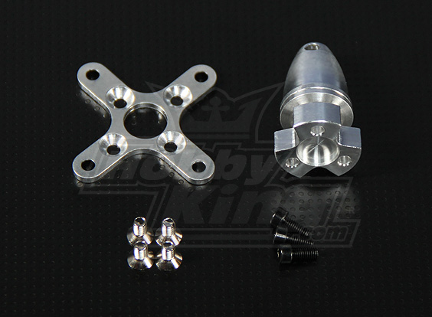

Standard accessory pack for NTM Prop Drive 28 series motors.

CNC Machined (take a close look at the cross mount, even that is machined rather than punched) from billet 6061 alloy for strength and balance.

The propeller adapter is a press fit to ensure balance.

**Specs:**

Shaft Diameter: **5mm**

Shaft Length: **19mm**

Cross Plate Bolt Holes: **34mm**

Weight: **13.8g (Total)**

Produced in-house by hexTronik to reduce costs and deliver better value to you!

Note: Ensure your propeller is balanced to avoid breaking shafts/bearings.

PRODUCT ID: NTM28-ACC

Battery Specs:

**This pack is suitable for the following models:**

Slash 4X4 Platinum

Slash 4X4 Ultimate

Slash VXL

Slash 4X4

Stampede VXL

Specs:

**Traxxas part no:** 2878

**Capacity:** 8400mAh

**Voltage:** 3S1P / 3 Cell / 11.1v

**Discharge:** 30C Constant

**Weight:** 614g (including wire, plug & shrink wrap)

**Dimensions:** 156x45x43mm

**Balance Plug:** JST-XH

**Discharge Plug:** TRX Plug

PRODUCT ID: 9067000012-0

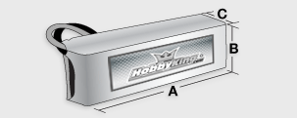

|  |  |
| --- | --- |
| Capacity(mAh) | 8400 |
| Config (s) | 3 |
| Discharge (c) | 30 |
| Weight (g) | 614 |
| Max Charge Rate (C) | 2 |
| Length-A(mm) | 156 |
| Height-B(mm) | 45 |
| Width-C(mm) | 43 |

**Propeller Specs:**

11x4.7 SF Props 4pc Standard Rotation (Yellow) complete with shaft adaptor rings.

PRODUCT ID: 9329000125

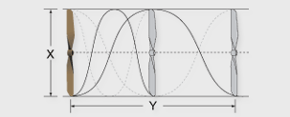

|  |  |
| --- | --- |
| Length (Inch [X]) | 11 |
| Pitch (Inch [Y]) | 4.7 |

**ESC Specs:**

Our TURNIGY speed controllers come with a 14 month warranty. We guarentee these are the best Brushless Speed Controllers you can purchase at this price.

These speed controllers are sold in western countries under various names at tripple the price.

We are certain you will find these to be the best BESC available from Asia.

Cont Current: 25A

Burst Current: 35A

BEC Mode: Linear

BEC : 5v / 2A

Lipo Cells: 2-4

NiMH : 5-12

Weight: 22g

Size: 24x45x11mm

Supported motor speed for all TURNIGY ESCs is;

(Maximum): **210000 RPM (2 poles)**, **70000 RPM (6 poles)**, **35000 RPM (12 poles)**.

User Programmable, both via controller and optional programming card. The programming card is an excellent item as it instantly tells the user the current settings and with a few simple clicks of the buttons, the user can change the settings and have graphical reassurance of those changes.

The programming card is an excellent Item and simple to use!